CP2406

Programming 3

Assignment Task 2

Keashyn Naidoo

# **User Stories:**

User Story 1:

As for the user I want to develop the traffic simulator customisation so that I can edit the car, bus, bike, and road and also the length, width for the road. Priority is high and estimated day is 2 days. For testing I want to develop the new city map and add more roads and then run the traffic simulator.

User story 2:

As for the user I want to keep the developed city and use it again later so that I make sure that all changes do not disappear from the customisation of the city. Priority is medium and estimate day is 3 days. For testing I want to save the new city customisation that was developed and save it with any name.

User story 3:

As for the user I want to reload the developed city into the traffic simulator so that I can run the traffic simulator again and see different situations like vehicles and changing lights in the traffic light when vehicles pass it. Priority is low and estimated day is 1 day. For testing I want open the saved city from the database so that I can access the saved city map.

User story 4:

As for the user I want to update the vehicles speed rate when I run the traffic simulator so that I can control how many vehicles I want on the road. Priority is medium and estimated day is 4 days. For testing I want to click on the speed button of the vehicle so that it can move faster or slower in the traffic simulator.

User story 5:

As for the user I want to stop the traffic simulator while there is still moving vehicles on the road. For that I want to terminate the running process of the traffic simulator. Priority is high and estimated day is 5 days. For testing I want to press the stop button to stop the simulation and watch all vehicles be terminated.

User story 6:

As for the user I want to try to avoid collisions with vehicles that are based on the distance that is ahead of an vehicle so that I can run the traffic simulator without any errors or problems. Priority is high and estimated day is 6 days. For testing I want to watch all vehicles carefully when the program is running.

## **Developer User Stories:**

Developed user story 1:

As a developer I can add colour changes to the traffic lights for the user and I removed the co-ords class from task 1 and recreated another class called field and also add 3 class to the road class. There are only 3 vehicles on the road and they are bus, car, and bike in the traffic simulator. Priority is high and estimated day is 2 days. For testing have public vehicle class and call some methods to move the car, bus and bike .

Developed user story 2:

As a developer I can also stop the all vehicles traffic to avoid collisions with the front vehicles and there will be no errors or problems I might face at all. Priority is low and estimated is 3 days. For testing I want to get the distance from the front vehicles and call some methods from the vehicles so that each vehicle knows when to slow down or move fast.

Developed user story 3:

As a developer I want make the program to save all the data that cannot occur or data that has been missing to the user. Priority is high and estimated day is 4 days. For testing I want to save all the data as a file at the main method and also to load the data when viewing the map.

Developed user story 4:

As a developer I want to load the data that has been created for the user so that all the data can be loaded in and run once the run button has been pressed in the traffic simulator. Priority is medium and estimated day is 1 day. For testing I want to show the specific path where the data file has been saved at the main method and so that it can read the data file and also load the data into traffic simulator.

## **UML Diagram:**

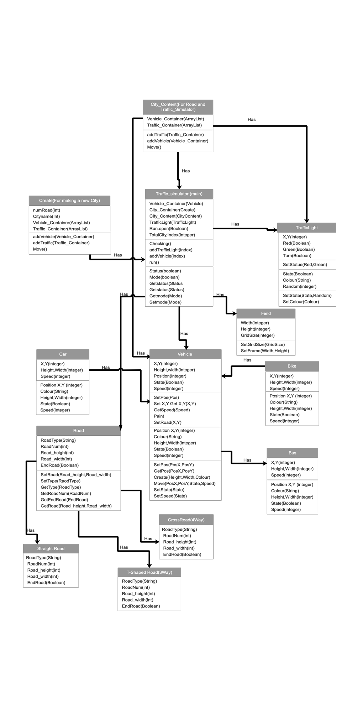

## **GitHub:**

<https://github.com/Keashyn/CP2406-Assignement-2-Traffic-Simulator-2.0-Keashyn-Naidoo>

